
The Islamia University of Bahawalpur
Office of the Treasurer
Purchase Section
No_ 7071 /PS
Date: 31-01-2020
NOTIFICATION

- It is notified for information of all concerned that University was floated tender in newspaper for procurements of IT items, for various departments. The General Purchase Committee of this University in its meeting held on 09-01-2020 opened the Technical Proposal Envelopes. The Technical Committee qualify the following firms for opening of financial bids:

Tender-IT Items for Various departments:

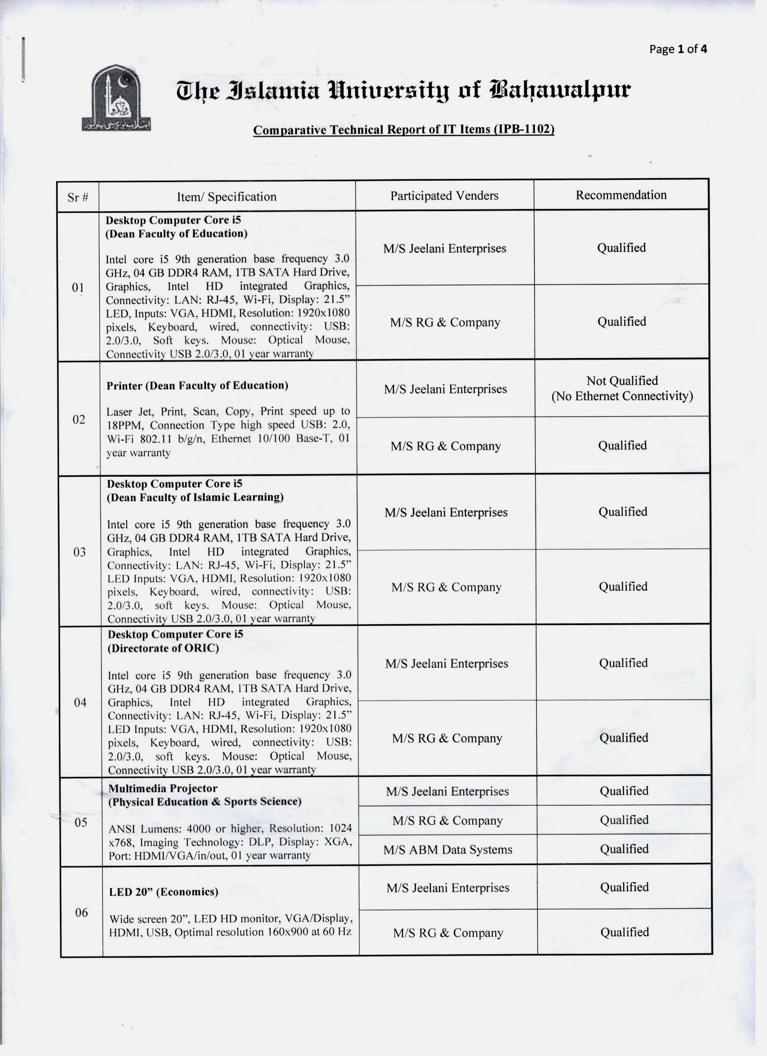

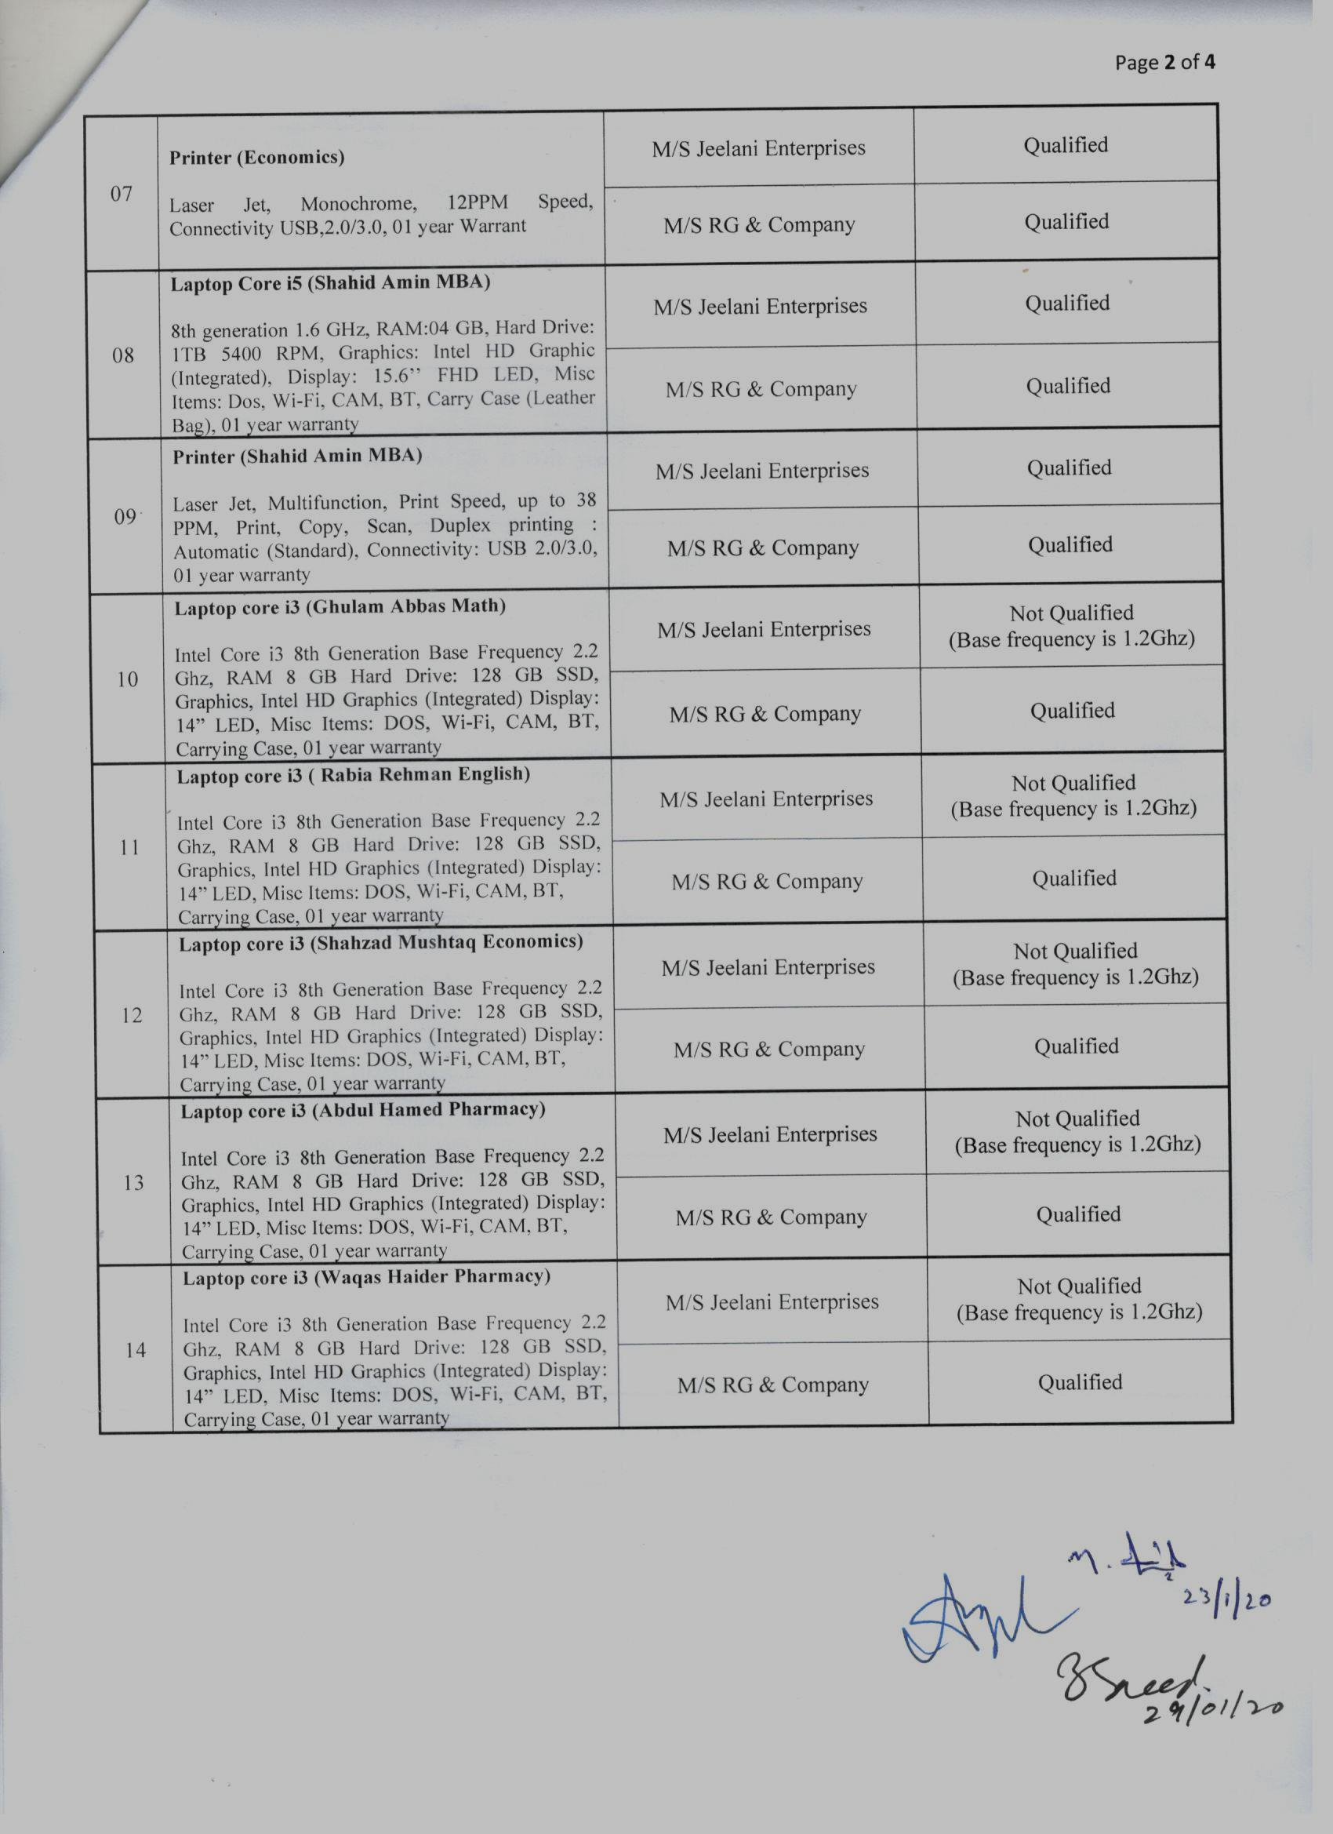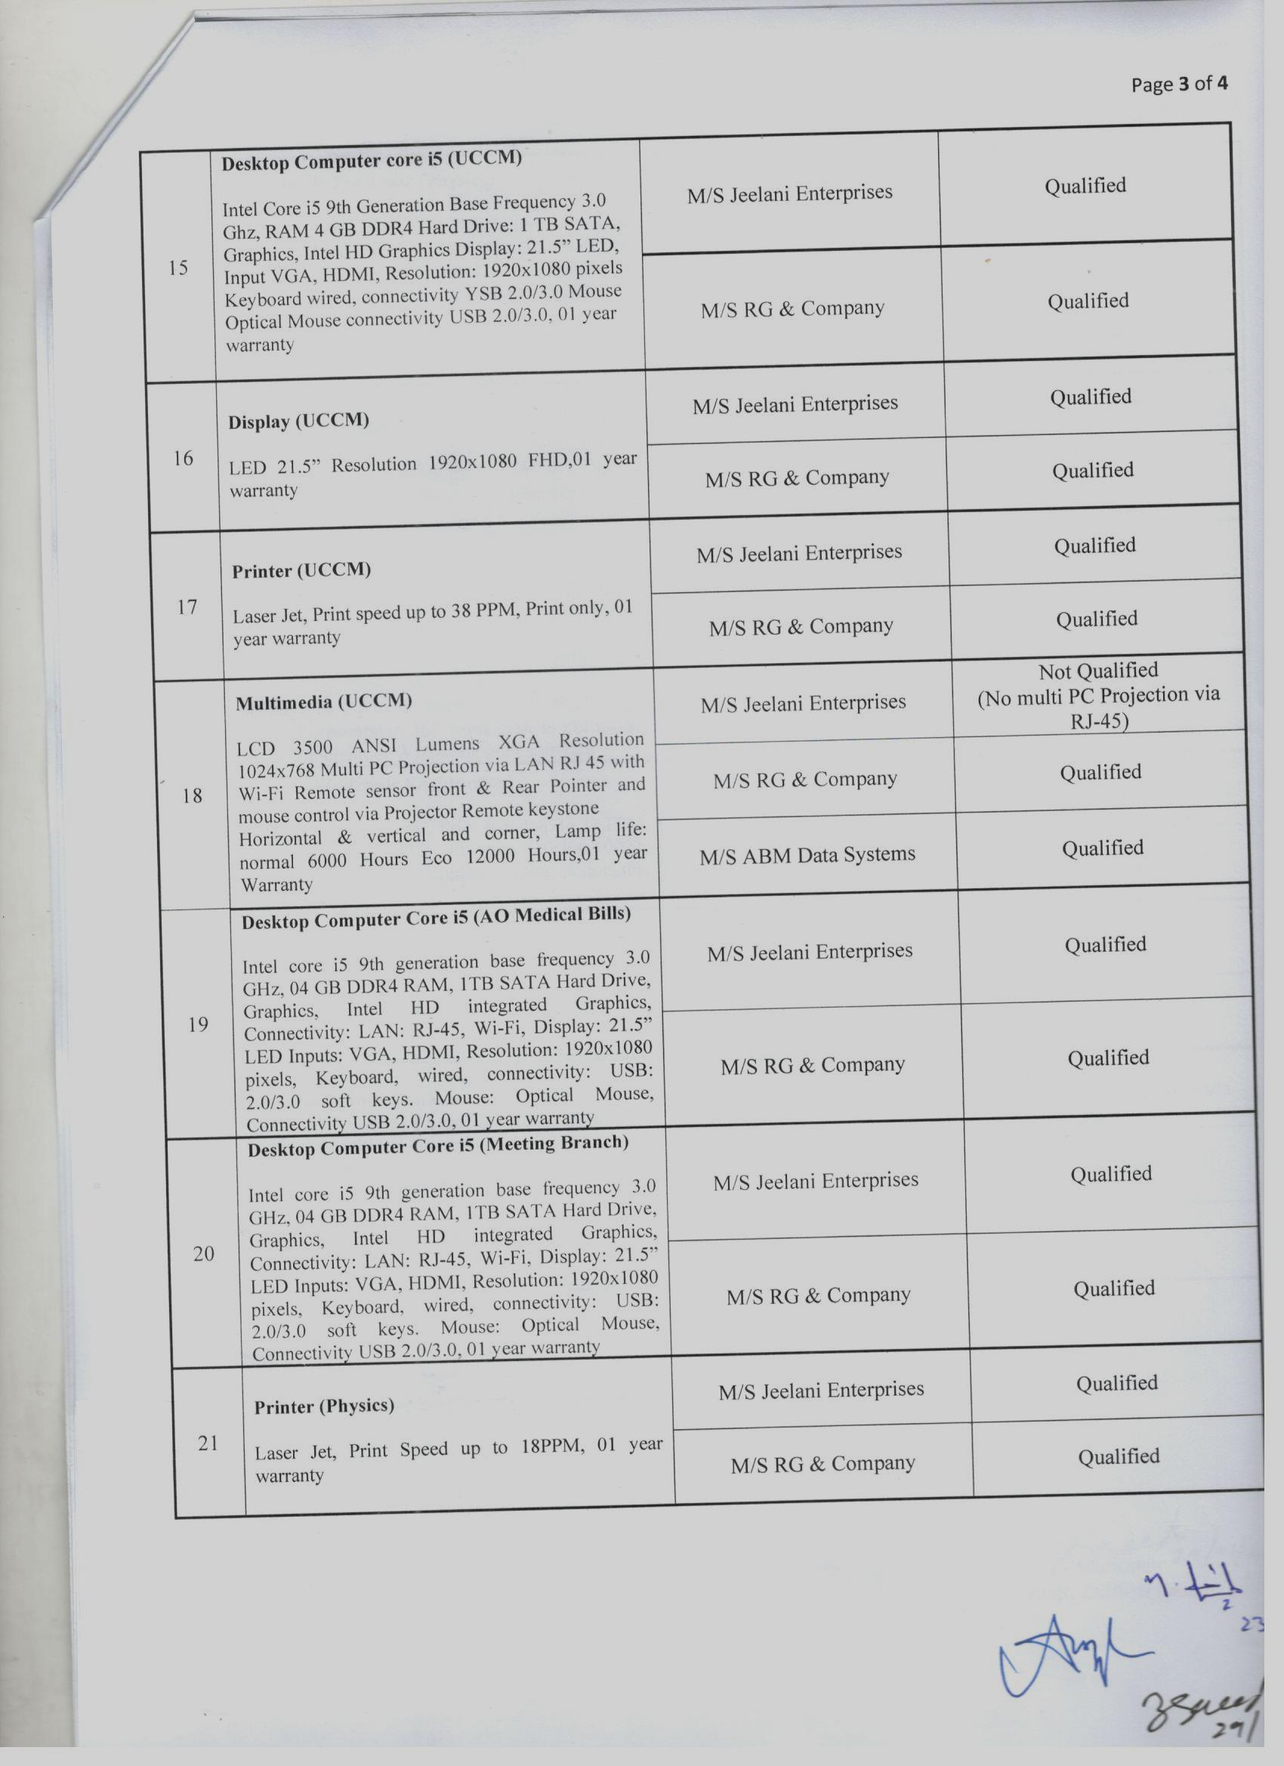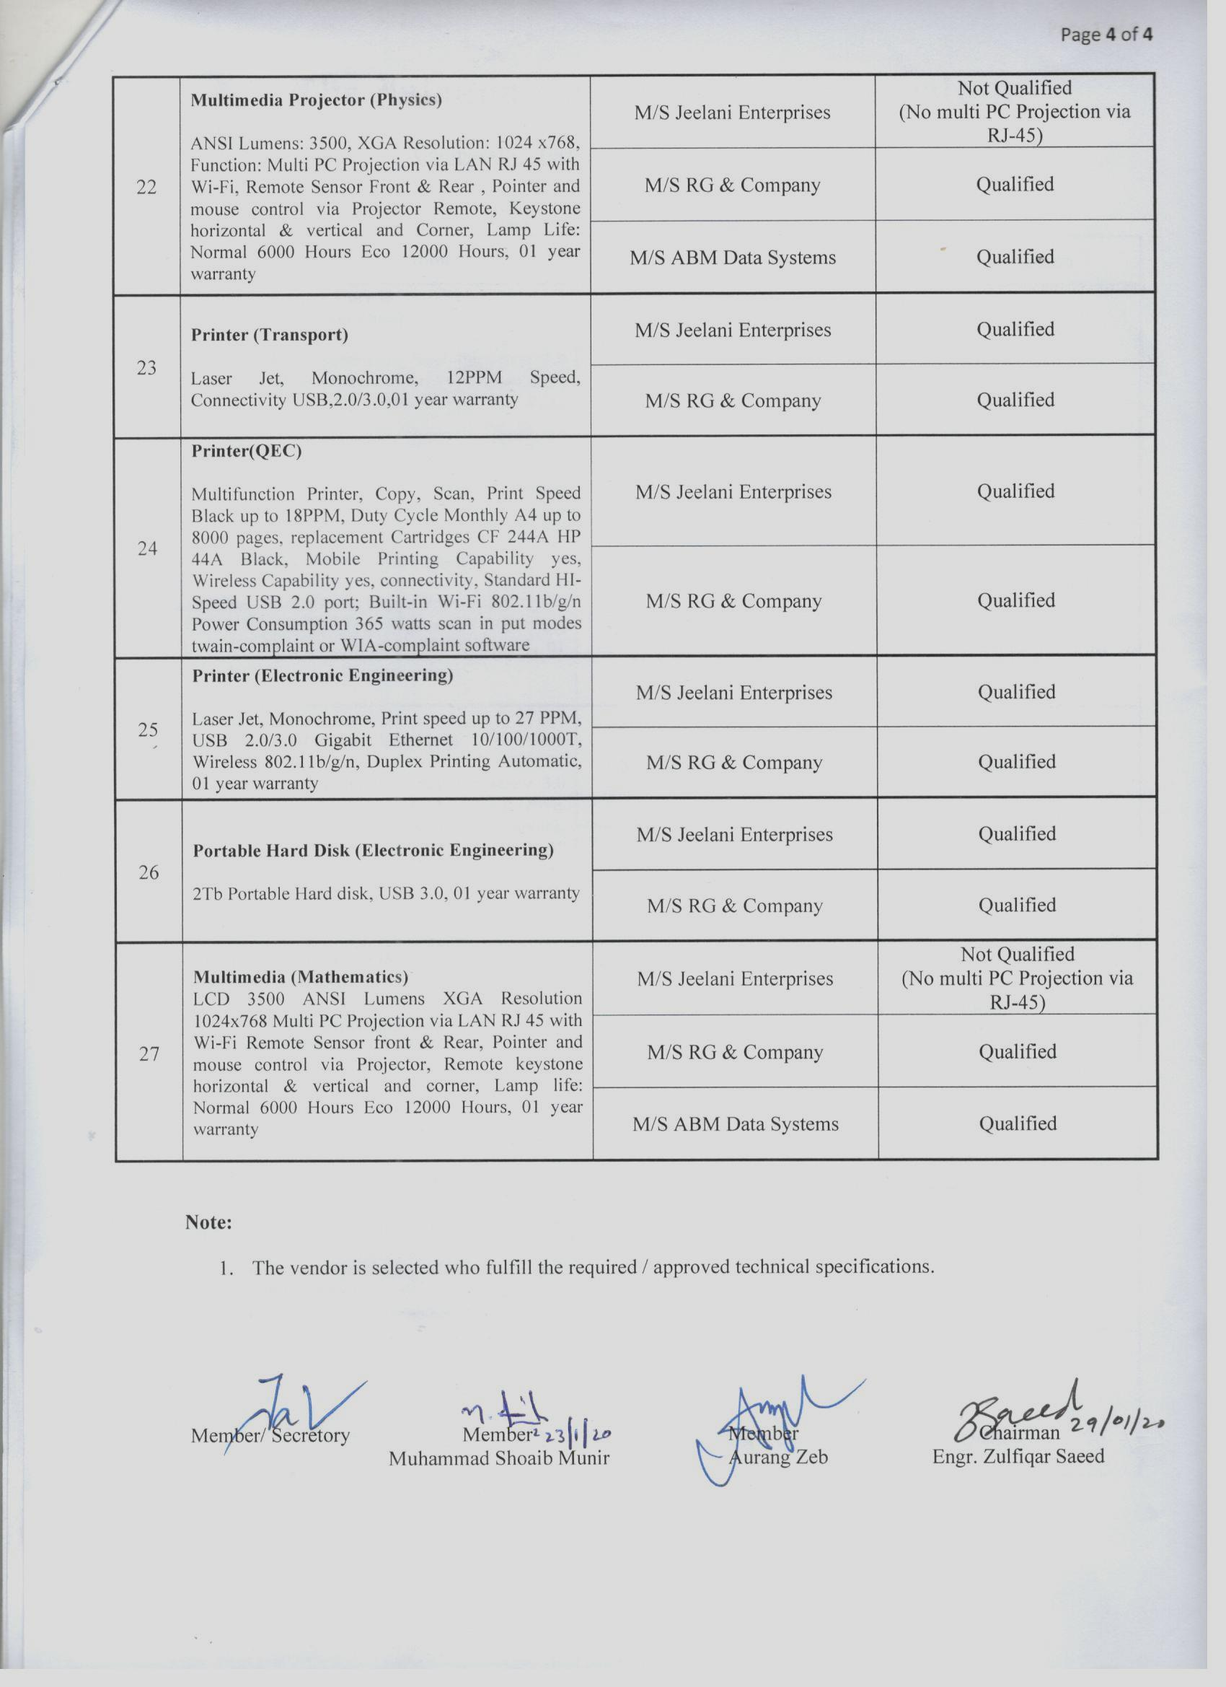

Date & time for opening of financial proposal will be conveyed to qualified firms through letter/telephonically

S-d/
Assistant Treasurer
For Treasurer

Office of the Treasurer, Abbasia Campus, The Islamia University of Bahawalpur.
www.iub.edu.pk, Email: treasurer@iub.edu.pk Ph.062-9250328

